Stock Market Data Prediction (Web app)

Minor project report submitted in partial fulfilment of the requirement for the degree of Bachelor of Technology

in

**Computer Science and Engineering**

By

**Shivam Verma (191455)**

**Jeet Dhamija (191377)**

**UNDER THE SUPERVISION OF**

Dr. Jagpreet Sidhu



Department of Computer Science & Engineering and Information Technology

#### Jaypee University of Information Technology, Waknaghat, 173234, Himachal Pradesh, INDIA

**Table of Contents**

## Title Page No.

Declaration by candidate III

Certificate by supervisor IV

Acknowledgement V

Abstract VI

Chapter 01: INTRODUCTION

* 1. Introduction
     1. Fintech 1
     2. Fintech in Stock Market Analysis 2
  2. Objective 3
  3. Motivation 3
  4. Languages Used 3
  5. Deliverables 4

|  |  |  |
| --- | --- | --- |
| **Chapter**  **(SDLC)** | **02: SOFTWARE DEVELOPMENT** | **LIFE CYCLE** |
| 2.1 | Feasibility Study  2.1.1 Technical Feasibility | 5 |
|  | 2.1.2 Operational Feasibility | 6 |
| 2.2 | 2.1.3 Economic Feasibility Requirements  2.2.1 Functional Requirements | 6  6 |
| 2.3 | Use Case Diagram | 8 |
| 2.4 | DFD Diagram | 8 |
| 2.5 | State Transition Diagram | 9 |

#### Chapter 03: IMPLEMENTATION

* 1. Date Set Used in the Minor Project
     1. Live Stock Data 10
  2. Date Set Features
     1. Types of Data Set 10
     2. Number of Attributes, fields, description of the data set 11
  3. Design of Problem Statement 11
  4. Algorithm / Pseudo code of the Project Problem 12
  5. Screenshots of the various stages (features) of the Project 14

#### Chapter 04: RESULTS

* 1. Discussion on the Results Achieved 17
  2. Application of the Project 17
  3. Limitation of the Project 18
  4. Future Work 18

We hereby declare that this project has been done by us under the supervision of

**Dr. Jagpreet Sidhu, Assistant Professor**, Jaypee University of Information Technology.

We also declare that neither this project nor any part of this project has been submitted elsewhere for award of any degree or diploma.

Supervised by:

**Dr. Jagpreet Sidhu**

## Assistant Professor (SG)

Department of Computer Science & Engineering and Information Technology Jaypee University of Information Technology

Submitted by:

#### Shivam Verma 191455

Computer Science & Engineering Department Jaypee University of Information Technology

#### Jeet Dhamija 191377

Computer Science & Engineering Department Jaypee University of Information Technology

III

This is to certify that the work which is being presented in the project report titled “**Stock Market Data Prediction (Web app)**” in partial fulfilment of the requirements for the award of the degree of B.Tech in Computer Science and Engineering and submitted to the Department of Computer Science and Engineering, Jaypee University of Information Technology, Waknaghat is an authentic record of work carried out by **Shivam Verma (191455)** and **Jeet Dhamija (191377)** during the period from January 2022 to May 2022 under the supervision of **Dr. Jagpreet Sidhu, Assistant Professor (SG)**, Department of Computer Science and Engineering, Jaypee University of Information Technology, Waknaghat.

#### Shivam Verma (191455)

**Jeet Dhamija (191377)**

The above statement made is correct to the best of our knowledge.

**Dr. Jagpreet Sidhu**

## Assistant Professor (SG)

Department of Computer Science & Engineering and Information Technology Jaypee University of Information Technology

### IV

We would like to take the opportunity to thank and express our deep sense of gratitude to our mentor and project guide **Dr. Jagpreet Sidhu, Associate Professor (SG)** for his immense support and valuable guidance without which it would not have been possible to work towards the completion of my pre-final year project.

We would also like to acknowledge each one of those well-wishers who have helped us directly or indirectly in making this project a win. In this unique situation, we would like to thank the various staff individuals, both educating and non-instructing, who always extended their convenient help and facilitated my undertaking.

#### Shivam Verma 191455

Computer Science & Engineering Department Jaypee University of Information Technology

#### Jeet Dhamija 191377

Computer Science & Engineering Department Jaypee University of Information Technology

## V

‘*The way we think about money or wealth in general depends highly on the type of economy we were born in’* [1], it derives the overall financial decisions we make as an adult. The concept holds very true when we consider the investments we do. Currently we are seeing one of the biggest surges in the stock markets. Even when the whole world was struggling during the peak pandemic and lockdowns, share markets were still up and running making profits to many. The *‘Bull’* never seems to stop any time soon, hence the topic *‘Stock Market Analysis’* becomes an interesting topic for a wider audience than ever, time and efforts are required to work on the same.

The web app proposed in this project deals majorly with the stock market analysis and has a minor component of prediction of the selected stocks. Web app displays the live stock market data using api in tabular form. The platform also comes with a feature of alert system which gives alert to the user whenever price of a particular stock hits a threshold set by the user. The platform also shows price prediction for the top stocks in the market.

The web app is of great importance for the side traders who have plenty of resources but not enough time to analyze a particular stock price. Such a web app can be easily used by first time traders also to analyze their portfolio’s performance. The app also focuses on the code less price prediction for the end users keeping in play.

The major motivation of this project is to create an end user friendly trading experience. The project’s future scope can be extended to other financial institutes including bonds, mutual funds, etc. (if data API are available).

VI

# Chapter 01: INTRODUCTION

## Introduction

Stock markets are one of the biggest and one of the most important financial institutions of any economy around the world. They can also be considered as one the most volatile financial institute. The share markets are gaining a wider audience (investors) by each trading day. To put it into perspective the Sensex grew approximately 132% in the last decade from 22,000 points in 2011 to 51,000 points in 2022[2], and now has the market cap of about Rs 202.84 lakh crore. Despite such promising growth there is a serious risk of losing a fortune in share market if the investment decisions are taken without any consideration.

The professional traders rely on various metrics of volume, new government policies, sentiment etc. while making their investment related decisions. The new traders as well as the side traders (professionals from other industries) find it difficult to break into the market. The coming of technology in the market has eased the process of investing but there is a need for more and more platforms which deal with the analytic side of the investment and stock markets in general. Therefore, the platform (web app) which focuses largely on stock market analysis, alert system and features like prediction to give the better chance at making financial decisions.

#### Fintech

Fintech is the combination of two words *Finance* and *Technology.* It includes products, technologies and business models that are already changing the economies around the world. The major implementation of fintech which are commonly seen includes using mobile phones aur web platforms for money transfer, bill payment, credit, loans, depositing checks etc. This multi-billion-dollar industry is rapidly growing majorly due to more and more people getting access to smart electronic devices and adapting to the ecosystem [3]. Fintech

ecosystems talk about doing financial transactions which a traditional institute like a bank will do but in a more efficient and streamlined way, in a way which is as user friendly as it can be. Fintech as a concept as well as an industry has revolutionized the micro lending and credit system, its ability to avail the advantages of financial institutes who otherwise were remote and inaccessible to traditional banks has helped many underprivileged people to come out of extreme poverty. It uses higher computing concepts like machine learning and advanced statistics to do tasks like asset management, credit scores and predictive analysis which are more reliable and at comparatively very affordable prices. The added advantage of fintech is its ability to let users make better financial decisions. Currently, India is the biggest investor of this market narrowly beating China [4]

It is important to highlight the disadvantages as well, the biggest disadvantage is security, in the digital interface everything is susceptible to data and worse financial thefts. The other disadvantages could be technological barriers, few tech giants gaining control over the entire financial system etc.

#### Fintech in Stock Market Analysis

Like all the other traditional financial institutions the coming of technology has revolutionized the Stock Markets as well and the way we used to think about it. The easement from opening of the account to investing in stocks has brought a whole new wider audience to the industry. When we talk about the analysis, currently we have multiple big startups in the country only working in stock market analysis only. The sector keeps on evolving due to continuous evolving predictive algorithms and analytical tools.

The digital interface has seen a massive growth of individuals investing on their own without any brokers, doing their own research and analysis with the historical data, news etc. available on the fintech platforms [5]. The industry has pushed many people with limited resources to also come in and invest due to the option of small investments. All in all, it has created a more friendly environment for investment by easing the paperwork and bringing side traders (people from other professions) to invest in large numbers but this digital system has also created a greater risk by making stocks more volatile and vulnerable to sentiment trading

## Objective

The digital space has created this ease of joining the stock market ecosystem and has brought more and more people into it, but the beginners or the side traders (people from other professions) find it difficult to navigate through this grey area of where and when to buy and sell.

The objective is to build a platform that brings overall ease of monitoring as well analysis of stock prices. The user can have a fair idea of when to sell and buy without wasting time by gluing to the platform. The platform also has minor features like prediction for the stock prices as well incorporated in it. The overall idea is to work on a one stop platform for all problems a beginner in this space might come across.

## Motivation

The profit-making window to buy and sell a particular stock is very slim and the new investors as well as side traders (professionals from other industries) may find it difficult to sell or buy at that time. The existence of this platform’s alert system gives them that luxury to be able to work side by side getting updates on their platform. The platform which shows live prices of the stocks to get an idea of what stocks are performing better and what otherwise. Although stock price prediction is a very vast domain in itself, in this platform (project) it is covered as a minor feature which gives predicted prices for stocks of top companies.

## Languages Used

The platform has two major components: frontend and prediction model.

1. **Frontend:** It is based on *python* Framework *Streamlit.*
2. **Prediction System:** It is based *Python’s* deep learning library *keras*

implementation of *LSTM* running on *python idle.*

## Deliverables

The end goal is to develop a web application or web platform which is a one stop solution for traders to ease the investment related decision-making process by providing following services:

1. **Analyses:** Feature to **monitor live stock prices** of different stocks to have an idea about best performing stocks.
2. **Prediction:** Minor feature to have a price prediction of stocks of the top companies

# Chapter 02 : SOFTWARE DEVELOPMENT LIFE CYCLE (SDLC)

## Feasibility Study

Feasibility Study is an important step in a Software Development Life Cycle (SDLC). This study tries to evaluate the feasibility of the software or product on multiple fronts like technology stack, financial feasibility, contribution of the project in solving the problem statement and whether that problem exists or not in actuality. Following are the perspectives or the feasibility points we have used to evaluate the feasibility this project:

#### Technical Feasibility:

The Software referred in this project is web enabled platform to analyze and predict stock market prices. The resources required can be divided as:

* + - * **Interface or the Frontend: It is based on *python*** Framework *Streamlit* It is compatible with major Python libraries such as scikit-learn, Keras, PyTorch, SymPy(latex), NumPy, pandas, Matplotlib etc.
      * **Data** for stock price prediction is available for free from *yahoo finance*.
      * **Model Training** is done using the free environment provided by *google colab* server using *Python libraries*.
      * **API** giving stock market live data is the most important resource required for the project, free *finance API* from *IEX Cloud provides this support*.

To conclude this section every resource used in this project is readily available as an open-source software or framework. The data services (api

calls) are also free and open to use but has slight **limitations of time delays** and **volume of data** fetched.

#### Operational Feasibility

The current website will be hosted on a free PAS (Platform as a Service) and does not require any maintenance unless the api used (**Yahoo Finance**) goes down which apart from that no other maintenance is required.

#### Economic Feasibility

As mentioned in 2.1.1 and 2.1.2 all the resources used in this project are free of cost and currently does not require any financial assets so the project itself is financially feasible at the moment. But it requires resources like faster and more

reliable hosting platforms, and a better stock market data API to make live data accurate and faster this requires finances to support.

The business model in above scenario has to shift from free platform to a paid subscription-based model to gain profits.

#### Requirements

The requirements evaluation and study are a very important part of the software development process. The success of the project in various terms of features and quality can be evaluated using requirements analysis. The requirement analysis can be divided into two types:

#### Functional Requirements

It talks about necessary features covered by the software to solve the given problem; it can also be described as the end features or functionalities the user sees or interacts with while using the software. The platform deals with the financial data and its manipulation to make data more interactive.

The following table shows the major functional requirements

|  |  |
| --- | --- |
| **Functional**  **Requirements** | **Functional Requirement Description** |
| Live Stock Data | Live stock prices in tabular form for analytic comparisons using API (https://finance.yahoo.com/) |
| Stock Search and Info | User can search any stock and find out its current price and key features of the company |
| Stock  Analysis on Bases of | Analysis of Stocks and visualization of Stocks in Graphical way |
| Stock  Prediction | Insights into major Company and their predicted stock price |

Table 1: Functional Requirements

## Use Case Diagram

Use case diagram represents all the interaction every user will have with the software in case. It will aid in representing the features available to every user across the platform

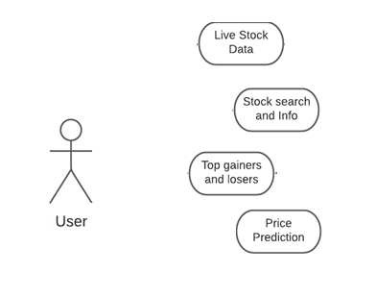

Figure 1: User Case Diagram

## Data Flow Diagram (DFD)

Data flow diagram (DFD) can be described as graphical representation of the information or the data flow in the platform.

The end objective is to highlight the scope and boundaries of a system or the project as whole

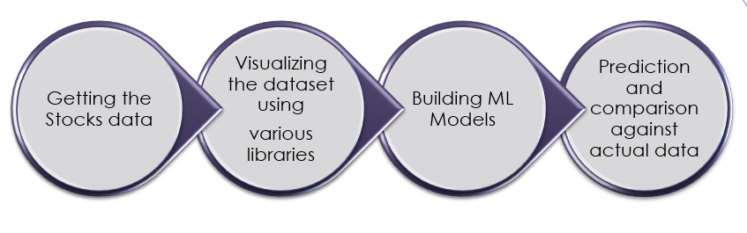

Figure 2: Data flow diagram

## State Transition diagram

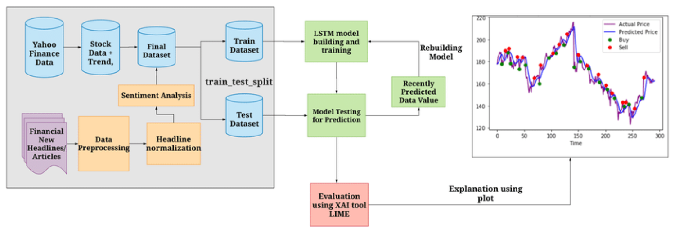

Figure 3: State Transition Diagram

The Start Transition diagram represents the behavior of systems. It describes all the possible outcomes of a process or state.

# Chapter 03: IMPLEMENTATION

## Data Used

The web platform uses one major datasets for its multiple features:

#### Live Stock Data

The Live stock Data is fetched using the finance. yahoo which provides a live data feed of the different stock prices and their information to be displayed on the web platform.

Link - <https://finance.yahoo.com/>

#### Dataset Features

* + 1. **Types of Datasets:**

The types of the following two dataset can be described as-:

**Live Stock Data -** The dataset used in this feature is fetched over real time using an yfinance. The API response updates on real time and hence the data can be described as the **Structured Real Time data.**

**Past Stock Data -** This dataset is used in prediction model to make prediction of the prices and is fetched automatically for each given stock (whose prediction has to be made) from past datasets using yfinance framework.

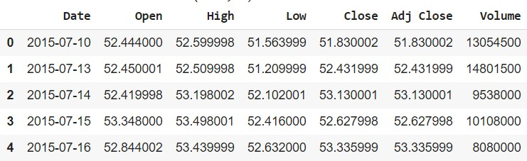

Table 2: Past Stock Data

#### Description of the Dataset (Attributes)

**Past Stock Data -** The stock data used in this has following features -

* + - * **Date -** The date of the trade used.
      * **Open -** The open price of the stock on that date.
      * **High -** The highest value of that stock in the given date
      * **Low -** The low value of that stock in the given date.
      * **Adj Close -** The adjusted volume set to closing of the market.
      * **Volume -** The total volume of the stock traded in the market.

#### Design of problem statement

The design of the problem statement can be understood by reflecting on the problem statement in hand and the solutions offered to tackle that problem in the platform.

##### Problem Statement

The Stock Market is attracting a huge audience towards it with digitization of the trading platforms, thus bringing people from all arounds of profession. There is absence of a singular platform for all the analytic problem revolving around trading namely -

1. Live stock data display and analysis
2. Reminder about the right time to sell and buy the stock to maximize the profit-making window.
3. Prediction of the stocks to plan financials.

##### Solutions Offered in the Platform

1. **Alert System** - Gives alert when the stock hits the threshold price set by the user.
2. **Prediction** - Gives the price prediction of the stock of top companies
3. **Analysis** - Live stock data and to search stock prices of any given stock.

#### Algorithm / Pseudo code of the Project Problem

##### Prediction Algorithm

The Algorithm used in this project is LSTM (Long Short-Term Memory) -

##### LSTM (Long Short-Term Memory)

Since the data in hand was that of *Time Series* in nature it becomes natural to use *RNN (Recurrent Neural Network)* it is a special kind of neural network which makes prediction based on past trends patterns for which it has loop like structure in its single cell structure which allows the data to flow or remain in the network itself for prediction,

But the problem with using a simple *RNN* is that it is not capable of holding large data i.e., it does not take into account a larger context of past data to make predictions for the next time series set.

This problem is addressed in *LSTM* it has special ‘*Memory Cells’* which are capable of storing data for prediction using larger trend analysis

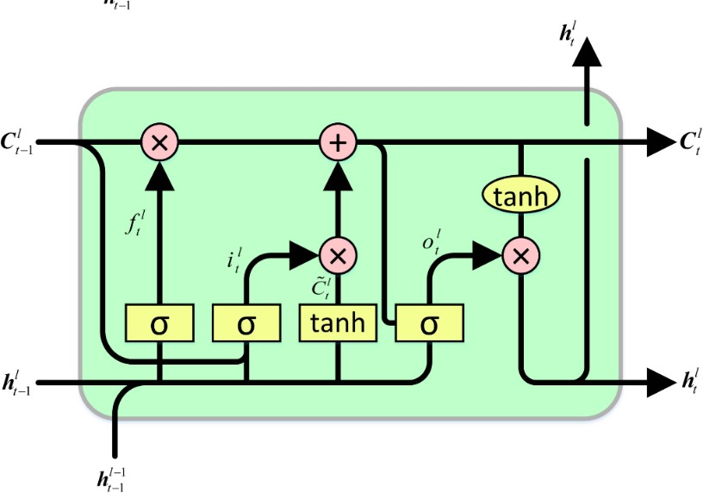

Figure 4: LSTM Cell Diagram

##### Pseudo Code for the web platform

* **Step 1 -** End User has an option to search the stocks as he wants.
* **Step 2 -** Clicking on the search box he will be able to enter the stock name.
* **Step 3 –** After Saucerful Entering the stock name he will get a small data set which is current statics of that stocks
* **Step 4 –** That statics dataset has all details of that particular stocks like std, min, max, mean, count 25%, 50%, 75% etc.
* **Step 3 -** After Entering the stock name the user will visualize the moving average from 100 to 200 days
* **Step 5 –** The actual vs prediction price of stocks will appear in the end after Moving average visualizing.

#### Screenshot of various stages (features) of the platform

This portion highlights the various major features of the platform and how they are implemented and are seen on the platform.

* + 1. **User Interface (Streamlit):** This is the actual User interface of streamlit web app portal.

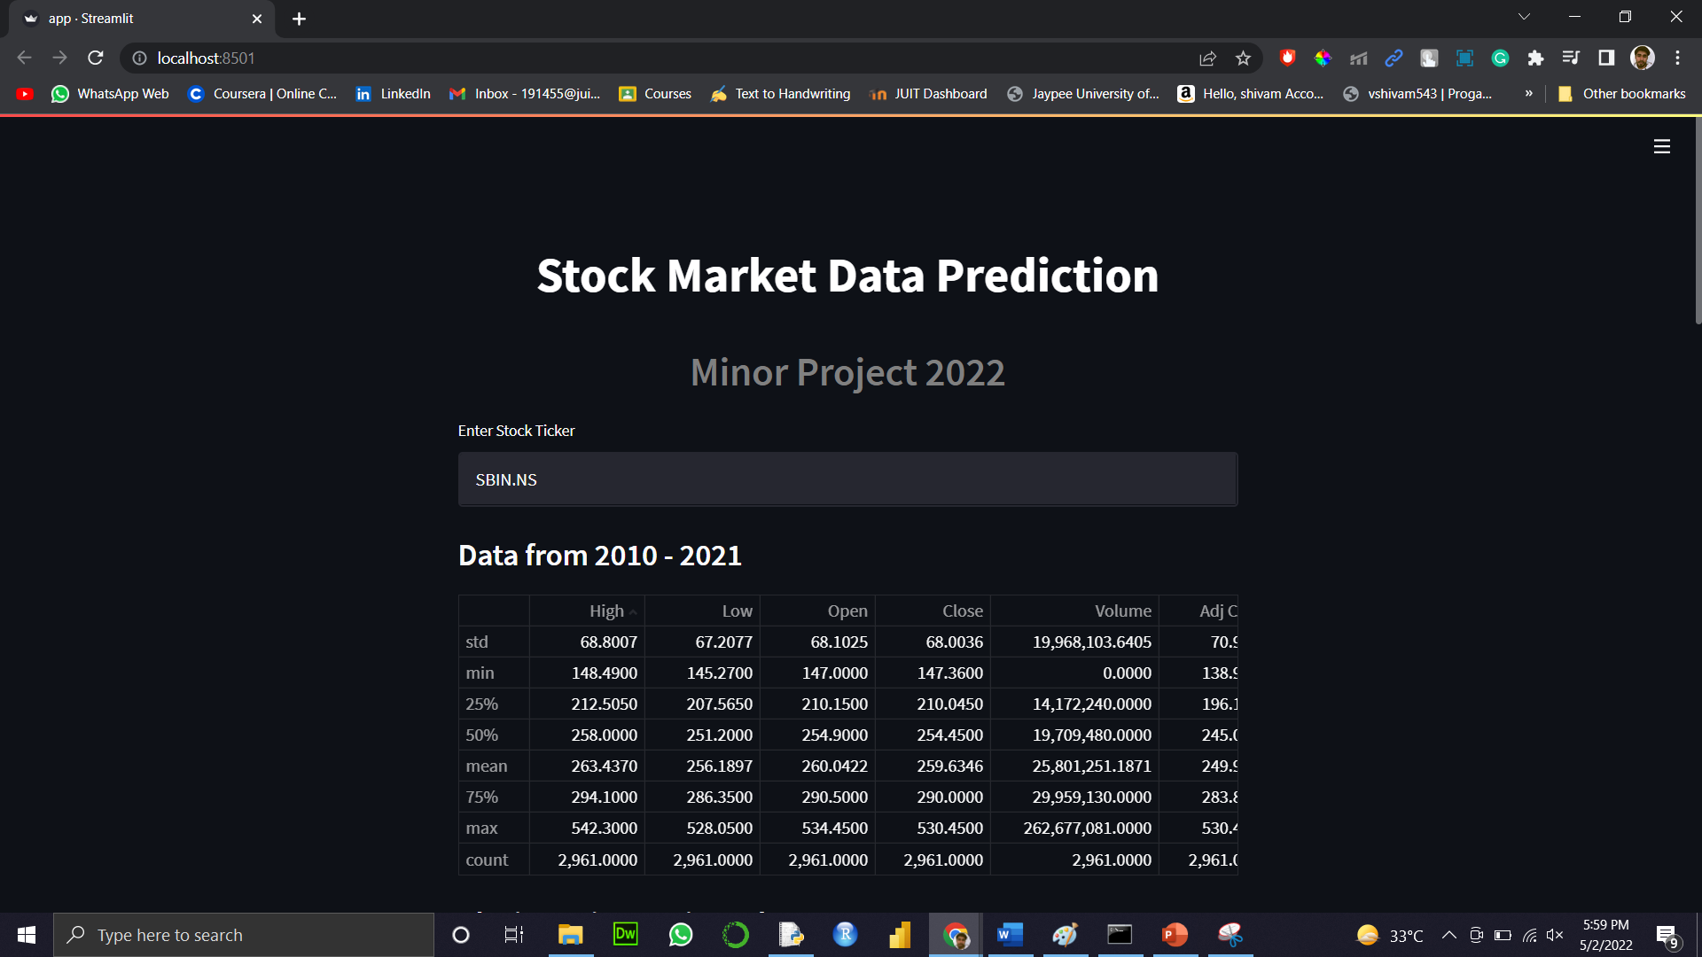

Figure 5: User Interface

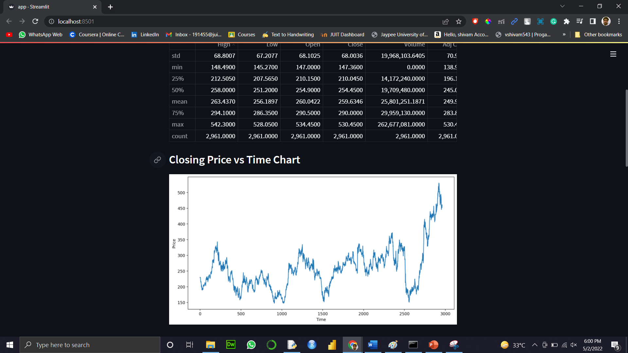

Figure 6: Visualization 1

* + 1. **Moving Average:** This feature is an indicator that shows the average value of a stock's price over a period

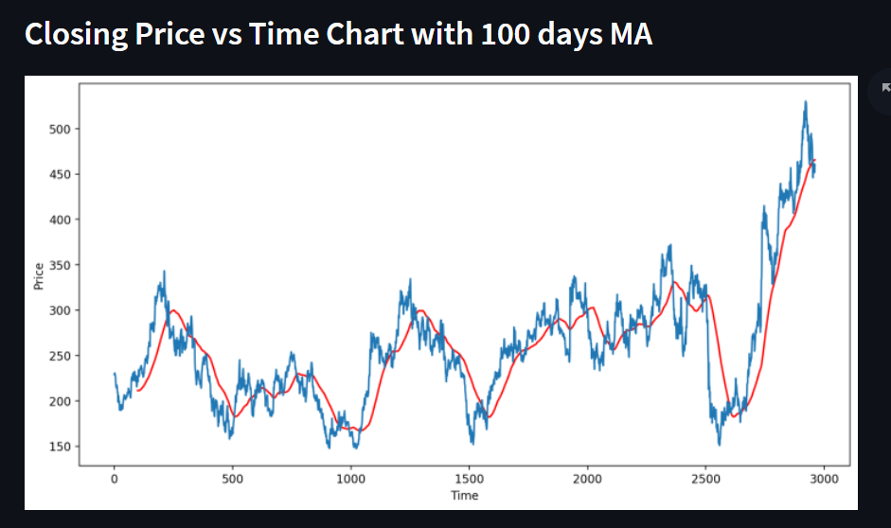

Figure 7: Moving average 100 days

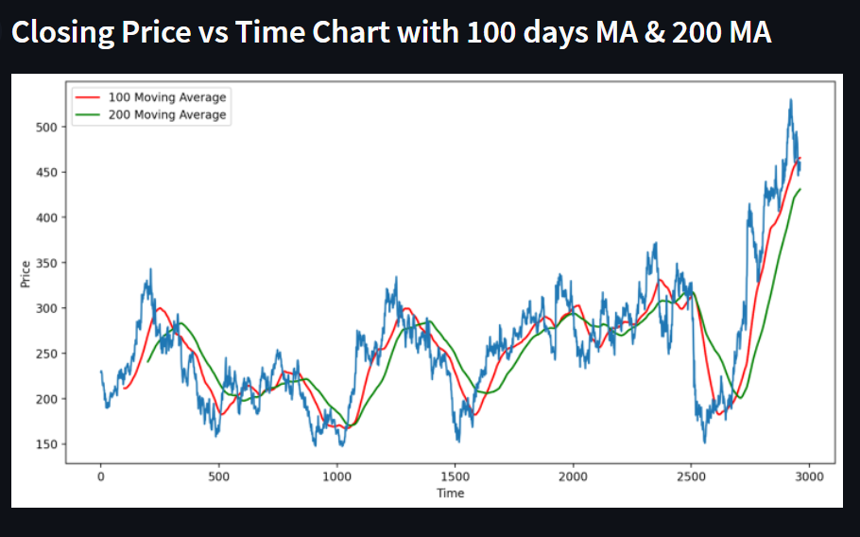

Figure 8: Moving average 100 days vs 200 days

* + 1. **Prediction -** Shows price prediction of the stocks of top companies.

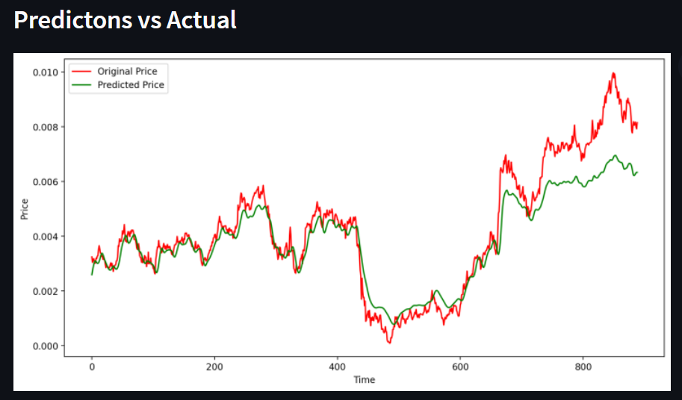

Figure 9: Price Prediction features

# Chapter 04: RESULTS

This section talks about the major results and takeaways from this project and various factors like limitations and future scope of the project.

##### Discussion on the Results Achieved

The final product of this project is a web enabled platform which had all the features included of -

* + 1. *Analysis* - Live stock data display with ability to search for any stock and has key information on it.
    2. *Prediction* - Displays the predicted prices of the stock of the top companies.

All the above-mentioned features target and solve every aspect of the target problem statement.

* 1. **Application of the Project**

The Project is an industry targeted project and can also be described as ready to use product.

This project or product offers features which were important to a big section of the traders but were offered currently by close to none fintech products on stocks out there.

#### Limitation of the Minor Project

The major limitations of this projects at this point are:

**API Limitations** - Currently the API used to fetch the stock data is a free version of the api and takes time to update and also has data send limit across to it

**Performance** - Currently the platform is hosted on a free web platform and has limitations in terms of load time and seo etc.

**Prediction Limit** - The prediction algorithms and techniques used in this

app is fairly and bare minimum, while stock price prediction is huge domain in itself and the one used here is a representational one and can in no way used to make investments.

#### Future Work

The Future scope of this project extends to providing a full stock market experience in terms of actual online brokerage and ability to make trades online. The future scope also extends to its application as automatic trading of positions of the user based on prediction and set threshold prices.

**References**

1. The Psychology of Money: Timeless lessons on wealth, greed, and happiness, Morgan Housel.
2. Yahoo Finance (2022), Sensex, Nifty end at their highest ever closing levels; rally for sixth consecutive session.
3. Investopedia, Financial Technology – Fintech
4. Indian Express, India beats China to lead investments in fintech among APAC nations: S&P
5. Forbes, Digital Transformation in Securities and Capital Markets
6. Streamlit, Amanda Kelly and Thiago Teixeira, Co-founders of Streamlit, on Empowering the Open-Source Community Founder Real Tal

# Plagiarism Report (Similarity Index)